2017 Mount Assiniboine Photo Tour
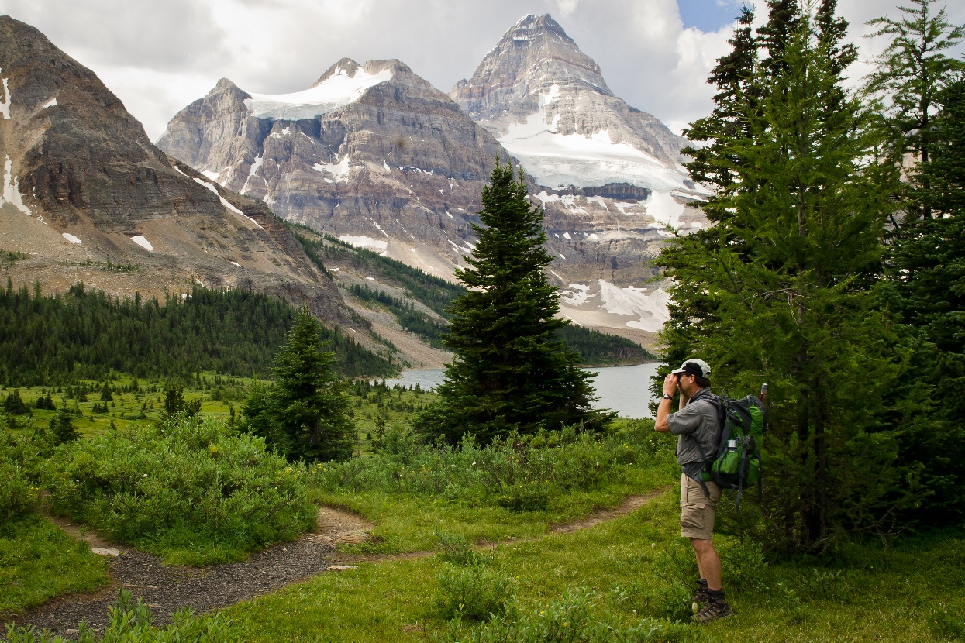
September 15 - 17, 2017
This tour is for those who enjoy tenting and a good hike in a breath taking venue. The tour will take place in and around the Mount Assiniboine Provincial Park.
The Canadian Rockies are an extremely popular destination for walkers, hikers, sightseers, naturalists and photographers. As such, booking accommodations at lodges and campsites is always difficult. To address this I have chosen a wonderful site, the Magog Lake Campsite, which has ample campsites and several options.
Getting There:
It is the responsibility of the participant to get to the Mount Shark Trail Head. From there Mount Assiniboine has a few options:

- One can hike into Lake Magog from the Mount Shark Trail Head (27 km)
- One can hike into Lake Magog from the Mount Shark Trail Head (27 km) and helicopter in and out you pack. There is a charge for this.
- One can take a helicopter from the same starting point in, hike out and helicopter out your pack.
- One can helicopter in and out.

Once at Lake Magog there are three options for accommodations, tenting at the Magog campsite, staying at the B.C Parks Naiset Cabins or staying at the Mount Assiniboine Lodge. The helicopter flight can be arranged just before the tour, however the cabins and the lodge fill up early. So if we are to have any hope of booking these, we need to know who is going and where you want stay. The lodge rates and the helicopter rates can be found at: http://assiniboinelodge.com/assiniboine-lodge

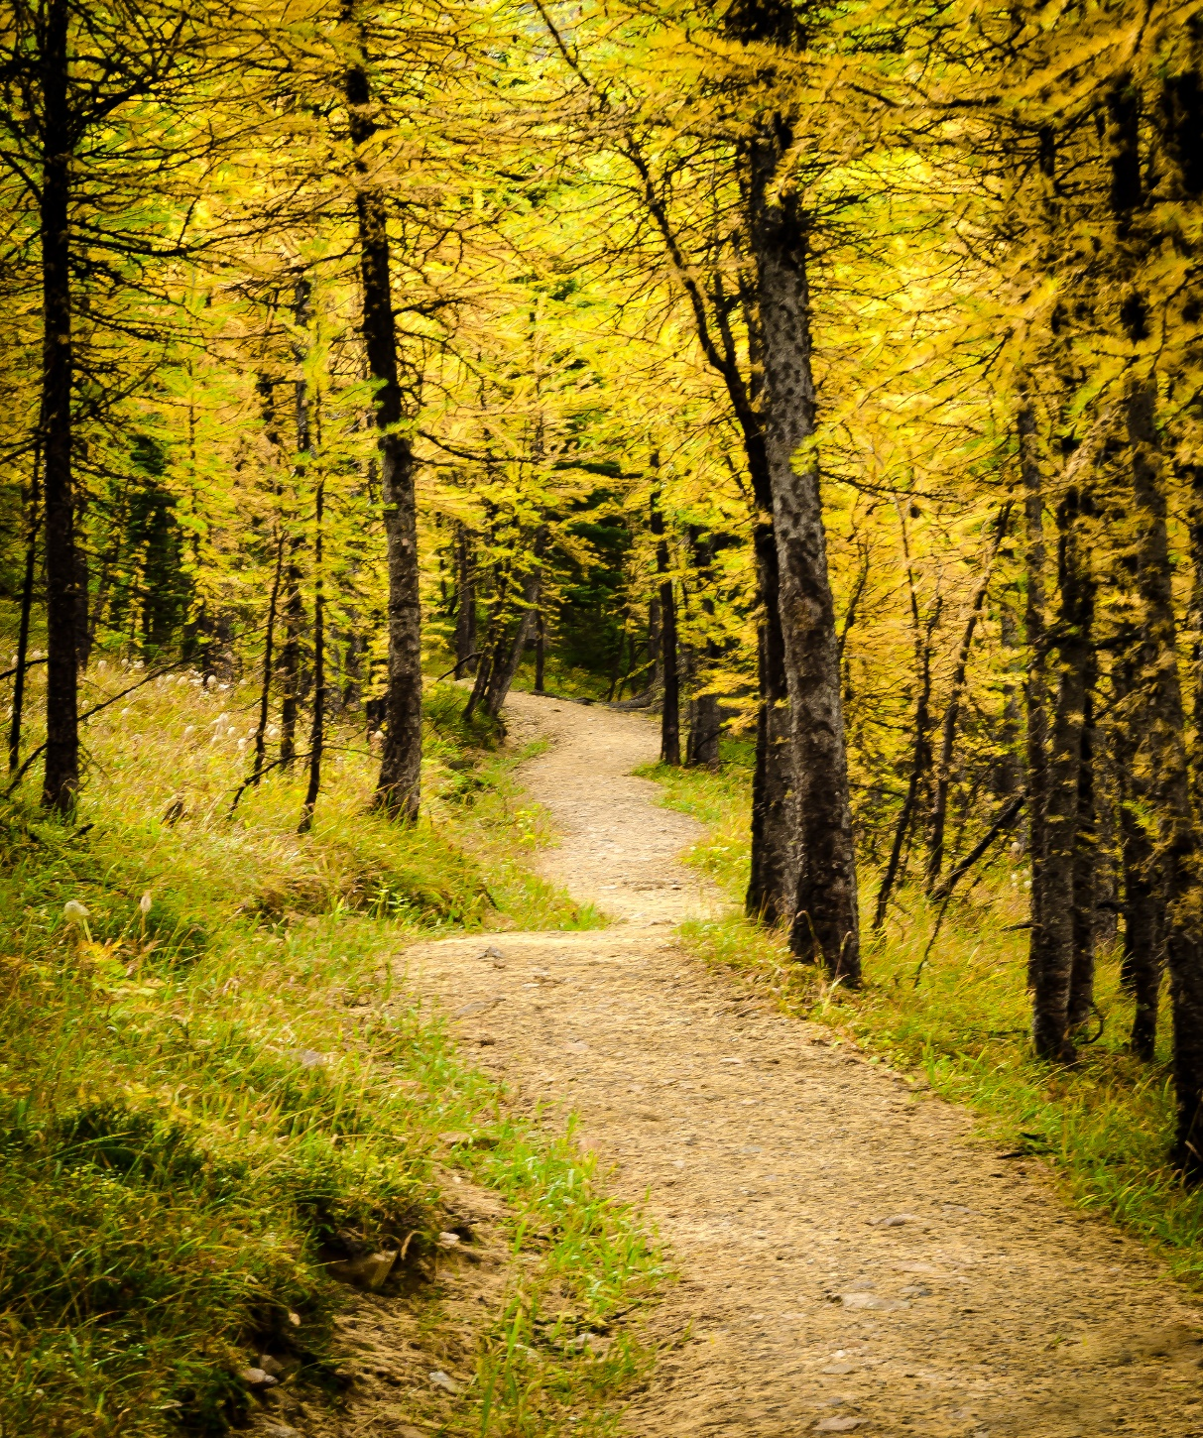

ITINERARY

(Because mountain weather is unpredictable, this a tentative itinerary. Times and photo locations are subject to change depending on weather and road conditions.)

The hike into Lake Magog is an easy 27 km if one takes Assiniboine Pass. There are some opportunities to take photographs but most of the time you are in the trees. If you hike in via Wonder Pass, there are more photo opportunities but there is one extremely steep portion that is no fun unless you are very fit. No matter which route you choose you should allow six to eight hours. If there is anyone who would prefer to hike in, I would certainly accompany them. However the cost of the helicopter is reasonable. If you fly in, you can take in more gear than you can hiking and you get more time to explore Mount Assiniboine Provincial Park where the photographic opportunities are mind boggling.

On our arrival at Lake Magog we can spend the afternoon photographing around the lake, there are interesting landscapes, reflecting ponds, flora and occasionally some wildlife. In Mid-September the sun sets around 7:55 pm and it rises around 7:15 am. So our first sunset shoot will be around Lake Magog. The evening light can be spectacular. We will be there just after the last quarter of moon (September 13), if the air is cool and the sky clear, we might get some wonderful moonlight images.

The following morning we will get an early start 6:00 am (bring your headlamps) and hike up towards the Nub, about one hour. There we will be able to photograph back towards Mount Assiniboine and Sunburst Peak. If the weather co-operates, the morning light is special. After sunrise we can continue to the summit of the Nub for tremendous panoramic view of the entire valley.

We generally try to make it back to Lake Magog for 3:00 pm in time for tea at Mount Assiniboine Lodge.

For the sunset shoot we will hike towards Wonder Pass. The larches at this time of year are outstanding. We will return to the same area in the morning for our sunrise shoot. Not only do we have fantastic views of The Towers and Terrapin Mountain but Gog Lake is a photogenic gem.

On the Sunday you can either hike out (this time I recommend you take Wonder Pass) or helicopter out. The hike is almost all downhill and takes about six hours, allowing for a couple of stops for photos.

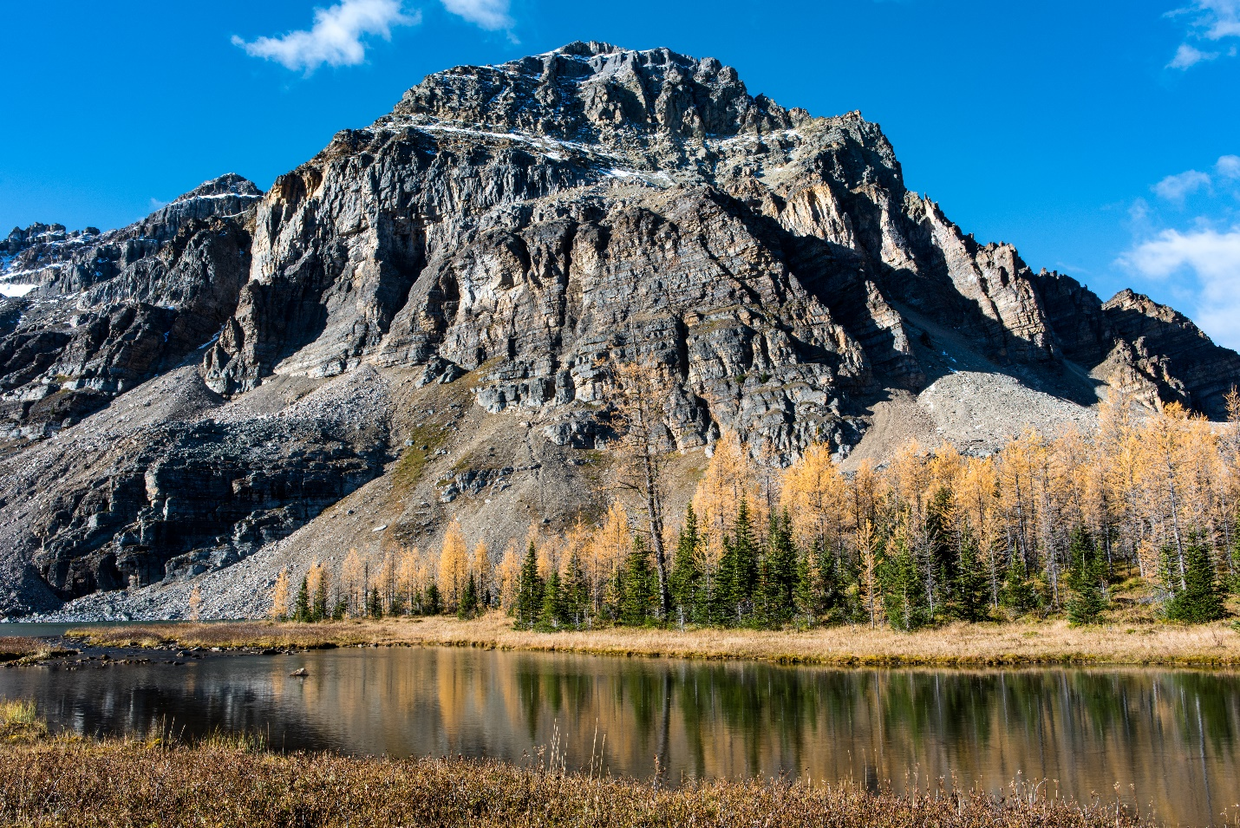

Equipment List
- Camera:
    - DSLR
- Lens Choices:
    - 28 mm f1.8 Wide angle
    - 50 mm f1.4 Normal
    - 85 mm f1.8 Standard
    - 24 – 70 mm f2.8
    - 70 – 200 mm f2.8
If you have prime lenses, bring a wide angle (like a 28 mm) and a longer lens (like a 50 mm). If you have a zoom lens, bring a lens that zooms into about 24 mm. (like the 24-70 mm).
- Other equipment:
    - Tripod
    - Remote shutter release
    - Filters
      - Polarizer
      - GND (2 stop soft, 3 stop hard, & 4 stop soft)
      - Filter holder
    - Extra batteries
    - Memory Cards
    - Kneeling pad
    - Camera Bag & Camera Cover
    - Loupe Hood
- Camping:
    - Tent
    - Sleeping Bag
    - Mattress
    - Cooking Utensils
    - Camp Stove
    - Food for 2 ½ days
- Clothing
    - Warm Jacket
    - Fleece or vest
    - Summer Hat and a Toque
    - Warm Pants and Shorts
    - Long Sleeve and Short Sleeve shirt
    - Good hiking boots
    - Gloves
    - Rain Jacket and pants
- Miscellaneous
    - Insect repellant
    - Sun tan lotion
    - Kneeling Pad
    - Head Lamp
    - Refillable Water Bottle

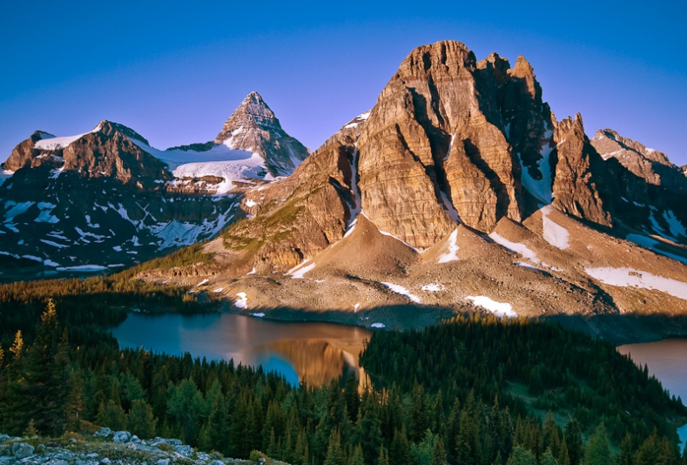

WHAT YOU CAN EXPECT

How to choose the best location for a given day and time. How to work an alpine site. What special considerations there are for shooting in the mountains? Composition beyond the rule of thirds. An in depth look at exposure strategies. Photographing in less than ideal conditions, (low light, overcast days, bad weather, extreme contrast etc.), post production tips.
Cost

The tour fee is $550 per person.

In addition, there is your cost of transportation, accommodation and food. I have set the cost out this way so people can decide which of these items best suits their circumstance. Please complete the attached information form. Once returned, I will provide you with a quote. With a deposit, I can then make all the reservations on your behalf.

While we are fully insured, all participants are required to sign a standard participant’s release and indemnity agreement prior to the tour.
Cancelation Policy. You may cancel up to 30 days before the event with a 25% penalty. After that there is no refund for canceling. This tour will proceed regardless of weather. (Sometimes the best images are produced during inclement weather.)
If you have any questions, email me at: david.buzzeo@shaw.ca

